
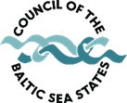
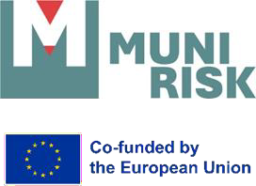
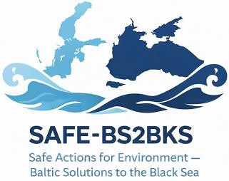


Project Meeting & Information Seminar for Policy Stakeholders
Report

Authors: Delove Asiedu, Hans Sanderson, Andriy Grafov, Frank Dugasseh, Andriy Martyenko, Michael Strangholt
Contents
1. Introduction 1
2. Workshop and Technical Sessions – Proceedings and Results 1
2.1 Workshop 1: Expert Group (BEPs for munitions' remediation and prioritization criteria model) 1
2.1.1 Results 1
2.1.2 Key Findings from Expert Poll 2
2.2 Workshop 2: Policymakers (Information seminar for policymakers) 2
2.2.1 Results 3
2.2.2 Key findings from the Mentimeter Poll for policymakers 4
3. Comparative Insights: Expert vs. Policymaker Polls 4
3.1 Main categories to drive remediation action 4
3.2 Environmental factors for prioritizing remediation areas. 5
3.3 Critical infrastructure/marine services for prioritizing remediation areas. 5

Figures
Figure 1: Expert responses (n =32) on factors for prioritizing submerged munitions remediation in the Baltic Sea. (A) Main risk categories driving remediation; (B) Environmental factors; (C) Security factors; (D) Infrastructure factors. 2
Figure 2: Policymakers' responses (n =12) on factors for prioritizing submerged munitions remediation in the Baltic Sea. (A) Main risk categories driving remediation, (B) Environmental factors, (C) Marine services, (D) Other factors. 4

Tables
Tabel 1. Comparison of main risk category priorities between stakeholder groups 5
Tabel 2. Comparison of environmental risk factor rankings between stakeholder groups 5
Tabel 3. Comparison of critical infrastructure/marine service risk rankings between stakeholder groups 5

  - Introduction
The overarching objective of the MUNI-RISK project is to support the HELCOM BSAP S34 and the EU Ocean Pact objectives regarding sound risk-based management of sea-dumped munitions in the Baltic Sea. Moreover, to ensure that the frameworks developed to do this are transferable to other seas, particularly the Black Sea. The objective is to better protect our environment and support the maritime industry in ensuring the sustainable development of the blue economy.

As part of this objective, Work Package (WP) 5 aims to ensure that the project's outputs are aligned with stakeholder needs, facilitating their incorporation into national and regional policies on submerged munitions in the Baltic Sea. To achieve this aim, there is a need to engage relevant authorities and stakeholders in co-developing the problem formulation for other WPs and to bring the project's outcomes to the policy level through meetings and participatory workshops.

Against this backdrop, a project meeting and information seminar was organized by the Council of the Baltic Sea States (CBSS) in Stockholm between March 10-12, 2026. The seminar was attended by experts and policymakers. We organized two workshops – one with experts and one with policymakers—where we discussed the same risk criteria for prioritization of sites for potential remediation to examine the positions and potential agreement or disagreement between the two groups on the criteria.

The seminar was organized within the framework of the EU co-funded MUNIMAP and MUNI-RISK projects and held back-to-back with their joint meeting with the HELCOM IC Expert Group on Submerged Munitions. Participants included representatives of the Polish CBSS Presidency, ambassadors and senior officials from CBSS Member and Observer States, as well as representatives from the European Commission and HELCOM. Experts involved in the MUNIMAP and MUNI-RISK projects also attended.

The seminar aimed to present ongoing work on the MUNIMAP and MUNI-RISK projects, facilitate stakeholder exchange, and discuss approaches to marine munitions risk assessment and remediation. A workshop and a technical session were held for experts and policymakers to inform and gather their perspectives on prioritizing remediation areas and identifying the best environmental practice (BEP) HELCOM BSAP S34. The proceedings and results are presented below.

  - Workshop and Technical Sessions – Proceedings and Results

2.1 Workshop 1: Expert Group (BEPs for munitions' remediation and prioritization criteria model)

The session began with a presentation by Prof. Hans Sanderson (lead scientist at Aarhus University) on the prioritization criteria models for remediating submerged marine munitions in the Baltic Sea. The presentation included integrated mapping layers from HELCOM and EMODnet, highlighting the distribution and density of munitions, as well as the intensity of marine ecosystem services and human use across the region.

Following the presentation, participants, mainly experts in marine environmental sciences, risk assessment and remediation and policy, engaged in an interactive Mentimeter Poll to rank the most critical marine services and uses to consider for prioritizing remediation areas. The poll questions and results are shown in Figure 1 (A-D).

2.1.1 Results
In total, 32 experts responded to the Mentimeter poll. The results for the risk categories to drive remediation action (Figure 1A) were analysed using a weighted ranking system (1st = 3 points, 2nd = 2 points, 3rd = 1 point). Security emerged as the highest priority, with a weighted score of 72 and 52% of respondents ranking it first. Environment ranked second, with a weighted score of 60 and 34% of respondents ranking it first. Infrastructure ranked the lowest with a weighted score of 39 and only 14% of the respondents ranked it as the first category to drive remediation action.
Regarding the risk factors for prioritizing remediation areas, for the environmental-related factors, marine protected areas and red-listed species were identified as the highest priorities, with weighted average scores of 8.34 and 8.13, respectively (Figure 1B). Fragile habitats (7.44) and important fish areas (7.13) were of moderate importance, whereas important bird areas (5.38) were ranked as the lowest.
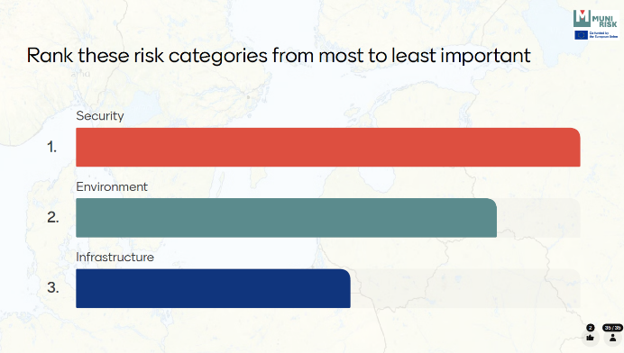
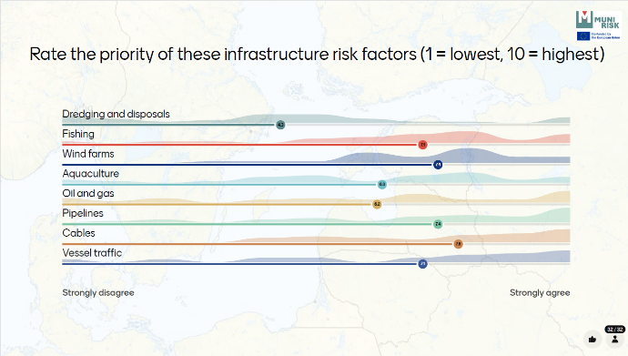
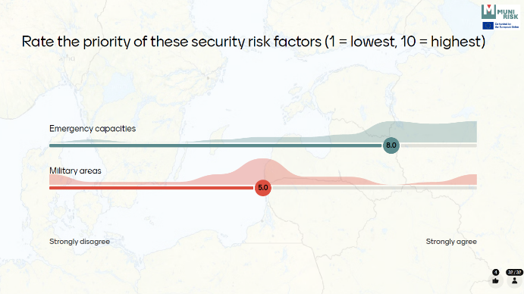
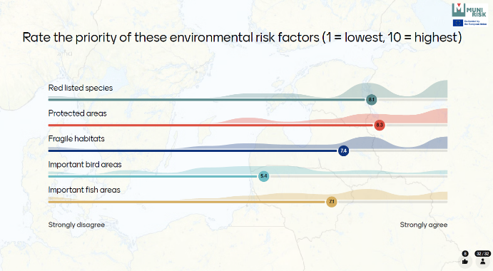
For security-related risk factors, emergency capacities (weighted average score = 8.0) were ranked as the top priority over military areas (weighted average score = 5.0) (Figure 1C). For infrastructure-related risk factors (Figure 1D), cables were ranked as the highest priority (weighted average = 7.8), followed by pipelines and wind farms (both 7.4). Vessel traffic and fishing areas were assigned slightly lower scores (7.1), while dredging and disposal ranked lowest, with a weighted average of 4.3.
A.
C.
D.
Figure 1: Expert responses (n =32) on factors for prioritizing submerged munitions remediation in the Baltic Sea. (A) Main risk categories driving remediation; (B) Environmental factors; (C) Security factors; (D) Infrastructure factors.
A
B.

2.1.2 Key Findings from Expert Poll
- Security should be the primary driver for remediation action.
- Cables, pipelines and wind farms are the most critical infrastructure factors for prioritizing remediation areas.
- Emergency capacities are the key security-related factor for prioritizing remediation areas.
- Marine protected areas, red-listed species and fragile habitats are the most important environmental factors for prioritizing remediation areas.

2.2 Workshop 2: Policymakers (Information seminar for policymakers)
This session brought together ambassadors and senior officials from the CBSS Member and Observer States. The session was moderated by Andriy Martynenko (CBSS secretariat), who also delivered the introductory remarks. Opening statements were given by Gustav Lindström (Director General, CBSS), followed by Szymon Bocheński (Polish Ministry of Foreign Affairs). Both speakers emphasized the high relevance and strategic importance of remediating submerged marine munitions in the Baltic Sea.
The session continued with a presentation by Domas Petrulis (Policy Officer, European Commission), who outlined the EU Ocean Pact and its implications for submerged marine munitions. He highlighted that the EU is developing a UXO removal strategy for European Seas, with particular focus on the Baltic and North Seas.
This was followed by concise scientific briefings from Prof. Jacek Beldowski (Institute of Oceanology, Polish Academy of Sciences) and Prof. Hans Sanderson (Aarhus University). Their presentations addressed the questions “What is in the Sea? What do we know about submerged munitions?” and “What do we know about the risks, and what are current research efforts within ongoing projects?” respectively.
The scientific briefings were followed by a dynamic question-and-answer session during which policymakers engaged directly with the scientists. The session concluded with an interactive Mentimeter poll, mirroring the format used in the expert group session. The poll questions and results are shown in Figure 2 (A-D).

2.2.1 Results
In total, 12 policymakers responded to the Mentimeter poll. A weighted ranking system was used in calculating the Mentimeter poll results (Figure 2A-C). For the categories driving remediation action, security emerged as the highest priority, with a weighted score of 30 and 67% of respondents ranking it first (Figure 2A). Environment was ranked second, with a weighted score of 17 and 25% of respondents ranked it first. Infrastructure was ranked the least with a weighted score of 12, only 8% of respondents ranked it first.
Regarding the risk factors for prioritizing remediation areas, for the environmental-related factors, marine protected areas were identified as the highest priority (weighted score = 43), followed by important fish areas (36), red-listed species (35), and fragile habitats (31). Important bird areas were ranked lowest, with a weighted score of 13. For marine services, cables were clearly prioritized (weighted score = 80), followed by pipelines (68) and wind farms (60). Other services, including oil and gas, fishing, dredging and disposal, vessel traffic, and aquaculture, received progressively lower scores of 50, 48, 45, 41, and 40, respectively.
Respondents also identified additional factors, including money (finances), environmental health, cultural heritage and tourism as important for prioritizing remediation areas (Figure 2D).

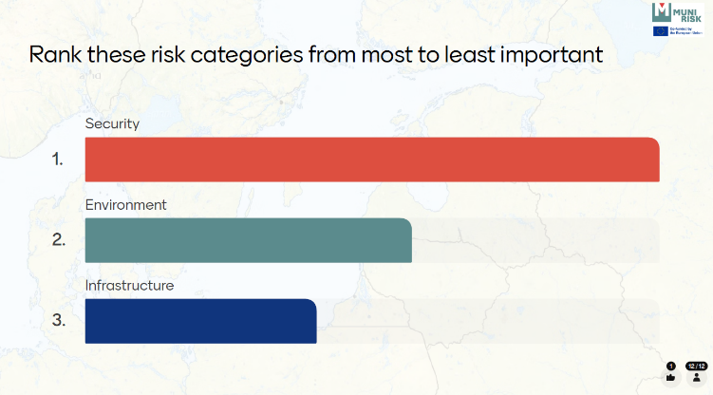
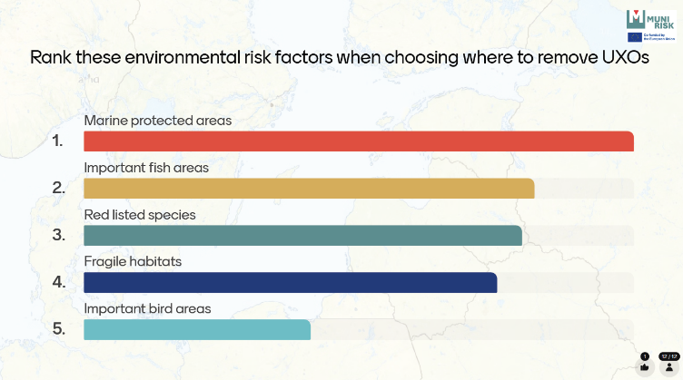
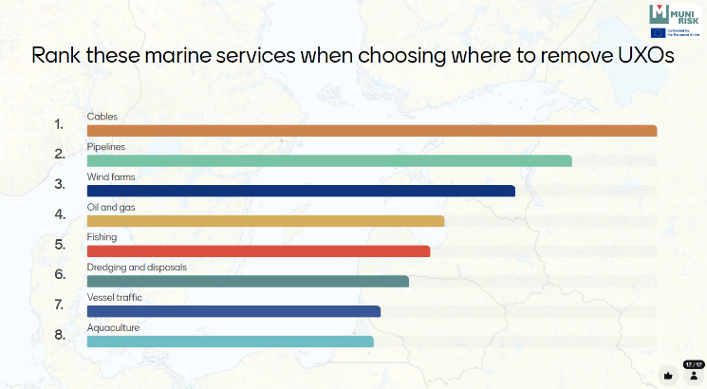
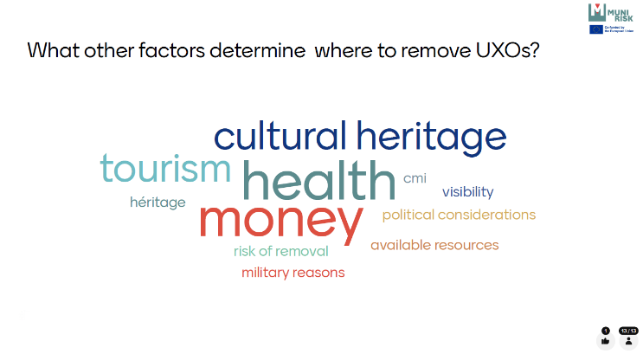
A.
B.
C.
D.
Figure 2: Policymakers' responses (n =12) on factors for prioritizing submerged munitions remediation in the Baltic Sea. (A) Main risk categories driving remediation, (B) Environmental factors, (C) Marine services, (D) Other factors.

2.2.2 Key findings from the Mentimeter Poll for policymakers
- Security should be the primary driver of remediation action.
- Cables, pipelines, and wind farms are the most critical marine services/ infrastructure for prioritizing remediation areas.
- Marine protected areas, important fish areas and red-listed species are the most important environment-related factors for prioritizing remediation areas.
- Additional socio-economic factors, including human health, finances, cultural heritage and tourism, should be included in the prioritization of remediation areas.

  - Comparative Insights: Expert vs. Policymaker Polls
Despite slight differences in question phrasing and response formats used in the Mentimeter polls, a strong level of agreement was observed between experts and policymakers regarding the prioritization of remediation areas for submerged munitions in the Baltic Sea. To enable comparison, responses were converted into standardized rankings, and agreement between stakeholder groups was assessed using Spearman’s rank correlation coefficient (ρ). Correlations were interpreted as very weak (0.00–0.19), weak (0.20–0.39), moderate (0.40–0.59), strong (0.60–0.79), very strong (0.80–1.00) agreement. Comparative results are presented in Tables 1–3.

3.1 Main categories to drive remediation action

Experts and policymakers ranked the three main categories in the same order: Security as the highest priority, followed by Environment, and then Infrastructure (Table 1). This resulted in perfect agreement between groups (Spearman’s ρ = 1.00). The findings indicate a shared understanding that remediation decisions should be primarily driven by safety and security concerns, while environmental and infrastructure considerations remain important secondary factors.
Table 1. The main categories driving remediation action, according to experts and policymakers.
Main categories | Borda score |  | Overall Rank
 | Experts | Policymakers
Security | 30 | 30 | 1
Environment | 26 | 17 | 2
Infrastructure | 23 | 12 | 3

3.2 Environmental factors for prioritizing remediation areas.

Strong agreement was observed for the environmental-related factors for prioritizing remediation areas (Spearman’s ρ = 0.70). Both experts and policymakers identified marine protected areas as the highest-priority factor and important bird areas as the lowest-ranked factor (Table 2). Minor differences were evident for intermediate priorities. Experts ranked red-listed species second, whereas policymakers assigned greater importance to important fish areas. These differences may reflect the stronger ecological focus of experts and the broader socio-economic and resource management perspective of policymakers.

Table 2. Environmental factors for prioritizing remediation areas according to experts and policymakers
Environmental factors | Mean score |  | Borda score |  | Rank
 | Experts |  | Policymakers |  | Experts | Policymakers
Marine protected areas | 8.3 |  | 44 |  | 1 | 1
Red-listed species | 8.1 |  | 35 |  | 2 | 3
Fragile habitats | 7.4 |  | 33 |  | 3 | 4
Important fish areas | 7.1 |  | 36 |  | 4 | 2
Important bird areas | 5.4 |  | 18 |  | 5 | 5

3.3 Critical infrastructure/marine services for prioritizing remediation areas.

For critical infrastructure/marine services, rankings were again strongly aligned between experts and policymakers (Spearman’s ρ = 0.73), demonstrating substantial consistency in perceived operational priorities. Both groups identified cables, pipelines, and offshore wind farms as the most important considerations for prioritizing remediation areas (Table 3). However, some divergence was observed for specific sectors. Policymakers assigned relatively higher priority to oil and gas activities, whereas experts placed greater emphasis on vessel traffic and aquaculture. This likely reflects differences between strategic governance considerations and technical or operational risk perspectives.

Table 3. Critical infrastructure/marine service for prioritizing remediation areas according to experts and policymakers
Infrastructure/Marine Services | Mean score |  | Borda score |  | Rank
 | Experts |  | Policymakers |  | Experts | Policymakers
Cables | 7.8 |  | 80 |  | 1 | 1
Wind farms | 7.4 |  | 60 |  | 2 | 3
Pipelines | 7.4 |  | 68 |  | 2 | 2
Fishing | 7.1 |  | 48 |  | 4 | 5
Vessel traffic | 7.1 |  | 41 |  | 5 | 7
Aquaculture | 6.3 |  | 40 |  | 6 | 8
Oil and gas | 6.2 |  | 50 |  | 7 | 4
Dredging and disposals | 4.3 |  | 45 |  | 8 | 6
The findings from the workshop and technical sessions demonstrate a clear and consistent prioritization framework for submerged munitions remediation in the Baltic Sea. Across both expert and policymaker groups, security considerations dominate decision-making, followed by environmental protection and infrastructure safeguarding. This shared hierarchy provides a strong basis for coordinated policy action at regional and EU levels.
The prominence of critical infrastructure, particularly cables, pipelines, and offshore wind farms, signals a growing convergence between environmental risk management and strategic economic interests, especially in the context of the green energy transition. This creates both opportunities and challenges: while remediation efforts may be accelerated by economic drivers, there is also a risk that less visible environmental concerns receive comparatively lower attention.
Overall, the strong alignment between stakeholders indicates that a common understanding of risks and priorities is already emerging, which can significantly facilitate the development of harmonized regional strategies.
By translating these insights into actionable policy frameworks, initiatives such as MUNI-RISK and MUNIMAP can play a pivotal role in advancing safe, sustainable, and economically viable remediation of submerged munitions—both in the Baltic Sea and in other European regional seas.

Disclaimer
Co-funded by the European Union. Views and opinions expressed are however those of the author(s) only and do not necessarily reflect those of the European Union or the European Executive Agencies. Neither the European Union nor the granting authority can be held responsible for those.

